University Management System

[ U. M. S.]

* ***Abstract –* In today’s contemporary world every work has started being online through internet. And mean time it is observed that if people are standing hours in large queue just to get admitted in the university. We have created a model of online portal of the university which provides service of admission, knowledge about and also contacting us while being at your comfort zone. This will help people save their precious time as well as their energy and get the service at their finger-tips in an instant. The model is based on database and internet programming. It is a web-based model.**

***Keywords*** *– UMS, digitalization, user-friendly, ease of access, one point for all data management*

INTRODUCTION

What is University Management System?

A cloud-based university management system (UMS) is a digital solution that helps automate tasks. Ranging from registering students, admitting students, onboarding them, managing their fees, managing payroll for lecturers to helping students access online learning, classroom training etc. a university management system is a complete solution. Reducing manual labour and intervention, this system ensures accuracy, transparency, reliability, and integrity of records, information, intellectual property and data.

In the current situation after pandemic most of the office work such as registration and application for admission in university, queries, contact, appointment, event handling, data management etc. are gone online and that days is gone when we had to wait in long que for hours to make anything happen such admissions, queries etc. At time people often stood in ques for hours waiting for their turn to get the things done. They wasted lots of their time and energy to get any office work done which took very long time. The staffs also struggled to find a single document from a mountain of files just to confirm few things. They have to maintain each and every person’s daily attendance, daily reporting of worker, teachers as well as students to make things fair and neat. This was a difficult task even for a group people to maintain all records accurately because there such a huge no. of people in the university having tens of thousands of students, thousands of teachers, about a thousand workers, hundreds of seniors and more. The staffs need to maintain all their reporting, their performance, their salary, the fees pending new registrations, removing data of students who left the university. They need to take care regular examination, seating arrangement, scheduling of each and every member’s routine from workers to all the way to senior executives. They need to take care of high-profile arrivals and meetings with them and also organising events. This was a way to difficult task to do only on papers. This resulted in a huge pile of files and folders and too hard to handle them all.

All the above gave rise to need of adopting new method to maintain and manage data where online method of making UMS came into vision. UMS stands for University Management System. Through UMS staffs were able count the reporting and attendance of each and every member in real-time. They were able to maintain all registration and admission very easily and contact with the client in real-time also troubleshooting any problems faced by the clients. This helped in regulating and maintaining and updating the data in real-time very easily and very efficiently while saving a lot of time of both client as well as staffs to do the same thing. This also enabled the developers to update the students, teachers or other members about any update in the regular schedule in the real-time. This help teaching easier by letting the teachers and students interact each-others any time anywhere. This also enabled teachers to provide the materials of the course to every student without any hassle. Now students are able uploads all the projects online and also get advantage of digital system. This also enables the members to act quickly on any incident and improved the relation between teachers and student.

Login Details

The UMS can be accessed through the UMS Login available on the University website http://www.lpu.in by logging in using the Username (student Registration Number in case of students and parents; and Employee ID in case of staff) and the Password.

For first time login:

The students should enter their Registration number as Username and the password as given to them at the time of admission.

The Staff should enter their Employee ID as Username as well as the default password.

Note:

The users can change their passwords at any time as per their requirement

This portal can be accessed as long as a student or a staff member remains enrolled with the University.

Details available on the UMS

E-Notice Board

UMS acts as an Electronic Notice Board and displays all important information and announcements made at the University level. The current happenings and achievements are also displayed on UMS.

Time Table

Under the Time Table section of the UMS, the schedule of classes along with details where the classes will be held, the block number and room number, is available.

Attendance

The Attendance Section of the UMS helps the students and staff to keep a regular track of their attendance. The student can check his/her up to date aggregate attendance as well as course wise attendance as and when required. The parents can also view and check their ward’s attendance status on regular basis.

Results

Under the Results Section of the UMS, the grades and marks scored by a student in every semester and the final CGPA till date can be viewed by the parents and the students. The marks/grades of previous semesters are also available for the continuous reference.

Assignments/Term Papers/Projects

With everything becoming tech savvy, the University’s procedure of taking assignments/term papers and projects has also been made online. The students are required to download the questions of assignments/ papers/ projects and submit the answers online through the UMS. Also the comments and marks on their performance are available online avoiding hassles of managing large pile of papers.

Date Sheet & Seating Plan for Examinations

Date Sheet of Mid Term and End Term Examinations is available on the UMS. To reduce the difficulties faced by students before examination for finding the examination seating plan, the seating plan for the exams with the room number allotted to a student is also available on the UMS.

Instruction Plans of Courses

Instruction Plan is a schedule of the syllabus to be covered by a teacher in lectures and contains details of text book, reference books and name of relevant Journals and Web links to be referred to. It also gives the brief idea about the home works and assignments that a student needs to submit in a given term.

The Instruction Plans of all the courses in which a student is registered is available online on the UMS.

Schemes and Syllabi

For the ready reference of students and teachers, the Scheme and Syllabi of all Programmes and Courses is available on the UMS.

Lab Manuals

The manuals of laboratory courses providing a complete list of experiments to be conducted by a student in a term, along with the guidelines, procedure and expected results are available on the UMS.

Book Search and other Library related Services

An online facility of “Book Search” is provided on the UMS that enables a student to search the location of required books, thesis/dissertations, compact disks and project reports by entering the name of the related book, thesis etc. If a student is unable to understand the basic terminology like Call No. of a library then he/she can note the number generated and the library staff will provide assistance in providing the required material to the student.

Online Registration for courses

Students can register online for the courses available for Departmental Electives, Open/Social Electives, Free Coaching Classes and Reappear or Backlog, if any, through the UMS.

Online Registration for Seminars/ Guest Lectures/ Workshops/ Cultural and Co-Curricular Events

The UMS makes it easy for the students to participate in any activity of the University by applying online. The student can get his/her name registered just by filling the online registration form.

Information and Online Registration for Placement drives

The UMS contains information about all upcoming placement drives. The students can register online for the placement drives conducted in the University.

The tests conducted during these drives by recruiters are also done via UMS.

My Profile

The UMS contains the complete profile of a student as well as a staff member consisting of Name, Father’s Name, Permanent and Correspondence Address, Contact Number, Email ID, and other students specific and staff specific information. The students and staff can update their profile.

Online Fee Deposition and Fee Deposition Slip

A student can deposit his/her fees in any of the branches of the banks with whom the University has collaborated, namely Punjab National Bank, State Bank of Patiala and Oriental Bank of Commerce and submit the receipt to the University. The details of Bank Account Number, fee slip and other details related to online fee payment are available in this section.

Fee Status and Fee Receipt

This section gives the details of semester-wise total fee of a student, fee paid so far and pending fees (if any). A student can download a soft copy of the Fee receipt of all fee payments made to the University. This helps a student to keep a track of the fees paid so far to avoid any discrepancy.

Interaction Schedule with Higher Authorities

To minimize the communication gap between the students and Senior Functionaries and to address their problems on time, Interaction Timings with Senior Functionaries are available in the student UMS. A complete list of names of Head of Departments, Heads of Schools, Heads of Faculties and other Senior Functionaries with interaction timings and place is given.

Centralized Departments

The UMS contains the details of Student Support Offices. Information regarding all the important offices and departments which provide ready services, along with their contacts and dealing areas is also provided to the students. Also the information about the vendors in the University is also available.

Campus Hospital

The students and staff can register themselves with the Campus Hospital through the UMS and the patient details are also available in the UMS.

Relationship Management System (RMS)

Relationship Management System (RMS) is an initiative by the University to properly attend to all the queries, suggestions, complaints , feedbacks and requests of a student pertaining to academic or non academic area and solve them in the best possible way and at the earliest. The student can make his/her point under the “Log Request” tab and as and when the issue is resolved the student will get feedback in the “view request status” tab, both displayed under “RMS”.

Online Surveys & Feedbacks

The periodic surveys by the University to get regular feedbacks from its students on the services and the policies of University are also conducted through UMS.

Miscellaneous Information

Under this, information regarding all the basic necessities of daily routine like food kiosks, canteens, stationary shop, Photostat and printer facility, superstore, parlour, saloon, computer cafe, boutique, banks ATM, mobile and laptop accessories, laundry , garment shop, sports good shop, shoe store etc. along with the physical location is given. It is convenient for a new student to locate such facility to get the required stuff easily and on time.

The UMS system is made for the students with a view to ease and simplify day to day activities of a student. The students are requested to make full utilisation of this system and make this University initiative a success. The University expects its students to regularly access the UMS at least two times a day and not to share the passwords with your friends, classmates or roommates.

Vendor Services

The UMS contains the details of all sorts of vendor services, like Canteens, Food Kiosks, Bookshops, Computer Café, Super Store, Banks/ ATMS, etc, available in the University along with their details and locations. There is an option to search the Vendor Services as per requirement.

Policies and Rules

The UMS contains the important policies and rules of the University to keep the students, parents and staff updated about them. The student UMS contains Fee related policies like Term Registration for Continuing students as well Freshmen, Term Off, Refund Policy for Continuing Students as well as Policies regarding Awards and Scholarships like Academic Honour to Regular students.

Medical Registration

Sh. Baldev Raj Mittal Hospital, the Campus Hospital offers round the clock comprehensive primary health care services to the students and staff of the University. The UMS contains the Medical Registration and the Patient Medical Details through which the staff and students can update their personal details and register themselves with Sh. Baldev Raj Mittal Hospital.

RELATED WORK

LPU promotes a culture of paperless University. The day-to-day administration and most of the University procedures are carried out online. The University Management System (UMS), an online portal of University, is one such innovative step of the University to provide vital information regarding academics and other University logistics for assisting the University students, their parents and the staff.

For making this model we have studied and researched thoroughly the UMS website of Lovely Professional University which includes checking its each and every section as a student. We saw that UMS is firstly asking for login then after that in the top right corner you can see your profile details and on its left side there are soe shortcuts to some important links such as ‘hostel booking’, ‘RMS’, ‘fee dashboard’, ‘academic calendar’, ‘Emergency number’, ‘certificate request’, ‘part time job application’ and ‘whatsapp’ link.

Then it shows the recent proud moments and events held in LPU on the headline beside which it shows all things happening in the university itself. Below that it shows the attendance of the member in percentage and can be viewed in details on clicking on ‘i’ button. Its right you can see your fees of the semester dues paid and all that then if you scroll down their it shows all the assignments that to be submitted by the student of each subject. Then its right ws all your ‘My Messages’ which shows the official messages send to by the authorities regarding your academics and important meetings. Then it shows the important upcoming events as well as going on events in the university. Then if you scroll-down you will see you will see the recent placements details such as how many students placed in company and at what ctc and there also a section which tells which company are here to heir students on what criteria.

On the extreme left of the UMS page you can see some shortcuts for daily use website such as ‘dashboard’ which is the page discussed above below that there ‘UMS Homepage’. It shows detailed description of your current performance and details from here student can download their virtual id card also. Below that we can see ‘LPU Live’. Here it is just like whatsapp but it is an official conversation area where groups are made by the superiors in which all the students of the section are their including their subject teacher are added. Groups are made subject wise there is a different group for different subject with different subject teachers and same students. Below that there is ‘LPU Touch’ which is a link to the LPU Touch mobile application which keeps informed and updated about your attendance, your classes, assignments, tests, marks, and much more. Below which we have ‘My Class’ which used to held online classes during COVID-19 pandemic. Here classes were all recorded and available for the students after an hour of the class. It was a one point stop for all the classes that held online. Then below there is your dost which is not used nowadays.

Now on the top of the page there some other links that are necessary for students in maintaining his/her cooperation with the college and its system. The links included are ‘Academics’, ‘Administrative’, Important Links’, ‘Student Service’, ‘Quick Links’ and ‘sign out’.

As of the model we have used HTML foe the main body and CSS for style of the model to look good. In HTML we have used some predefined tags that are very useful in making the website look good and simple.

1. ‘meta’ tag - To represents various kinds of meta data which cannot be expressed using the title, base, link, style, and script elements.
2. ‘title’ tag – to represent to document’s title or name
3. ‘link’ tag – to link CSS file to the main source code and other resources.
4. ‘div’ tag – it is used to mark up semantics common to a group of consecutive elements.
5. Class – it is used to allow CSS to select and access specific elements via the class selectors or function.
6. ‘Href’ – to give path to some media files.
7. ‘H1’ tag – to represent a section heading.
8. ‘ul’ tag – ul elements represents a list of items, where the orders of the item is not important

e.i. where changing the order would not materially change the meaning of the document.

1. li tag – it elements represents a list item. If the parent element is an ol, ul, or menu elemen,

then the element is an item of the parent element’s list, as defined for those elements.

1. Img – to insert the image
2. Button tag – the button element represents a button labelled by its contents.
3. Head tag – the head element represents a collection of metadata for the Document.
4. Body tag – it represents the content of the document.

NOVELTY OF PROPOSED WORK

Since, LPU is such a large university and so much population that handling its records and data is too hard. It is almost impossible for the staffs to maintain such a huge database without problems and errors. This model helps the university to maintain its all kinds of records, data and update them regularly in one point at their ease and comfort. With UMS it has become easy to maintain, regulate and update the records and data regularly and in real-time. Now clients can also raise their complains directly from the UMS. They can make and manage their profile, make changes and it see their course plan, their activity, keep a live track on their attendance, fees, salary, upload the required documents, give application for any academics related work. Even UMS is providing the daily happening in the university like about the placements, the events going on, registration for special courses, and also any big and small announcement about routine change or an important-events. This is a user-friendly website where user can interact with the website easily and get the things done while being at the leisure and comfort.

PROPOSED MODEL

The proposed model is a simple and user-friendly website which has some amazing features that can be added to the UMS of LPU to make it more user friendly and make the user even more satisfied with the working of the management system. To make this UMS website we have used HTML and CSS in order to make appealing to users and to make it easy to use.

This the screenshot of the website that we have created

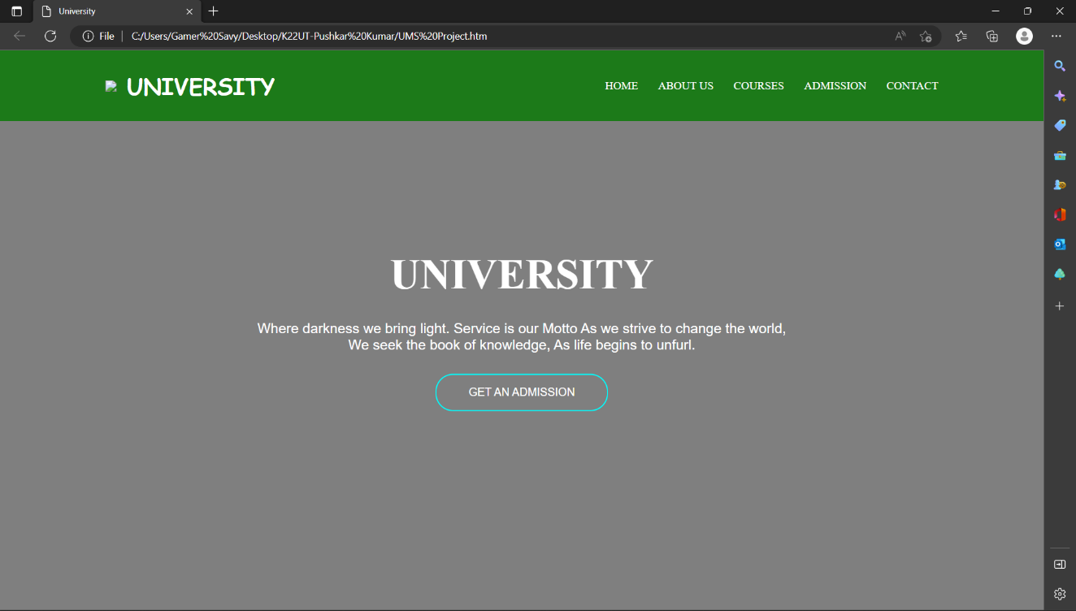

SIMULATION/RESULT

The main functioning of the website starts with registration for whether you are teacher or student or any other member of the LPU you want to become, so starting with the step by step

1. Open your browser.
2. Visit to [www.lpu.in](http://www.lpu.in)
3. Choose how you want to join LPU
4. Contact the lpu members for the id and password for UMS
5. Login at [www.lpu.ums.in](http://www.lpu.ums.in)
6. Access all the features UMS has to offer.

CONCLUSION

UMS has become very important in the day too day use of the students, teachers and other members of the LPU in order to be updated about happenings in the university and for and queries related to the administration, rules and regulation. This also contributes in digital India as LPU is also training people to work on the computer and cloud computing and spreading the knowledge and awareness about the computers.

The purpose of the model is to aware the public about working, functioning, and importance of the university management system to let people make the maximum profit of it

FUTURE WORK

We are working on the UMS for providing the best service we can by improving it day by day.

We are also taking all the feedback about the UMS website and improving accordingly to satisfy the need and convenience of as more users as possible. We commit to keep this website clean, simple and also update with the latest features that will be available in future so that ours can also enjoy the latest technology and their functioning for the best experience possible to our users.

REFERENCES

University Management System of Lovely Professional University and its functioning.

W3shool html

W3school CSS

Youtube